.NET - M7 Assessment 1

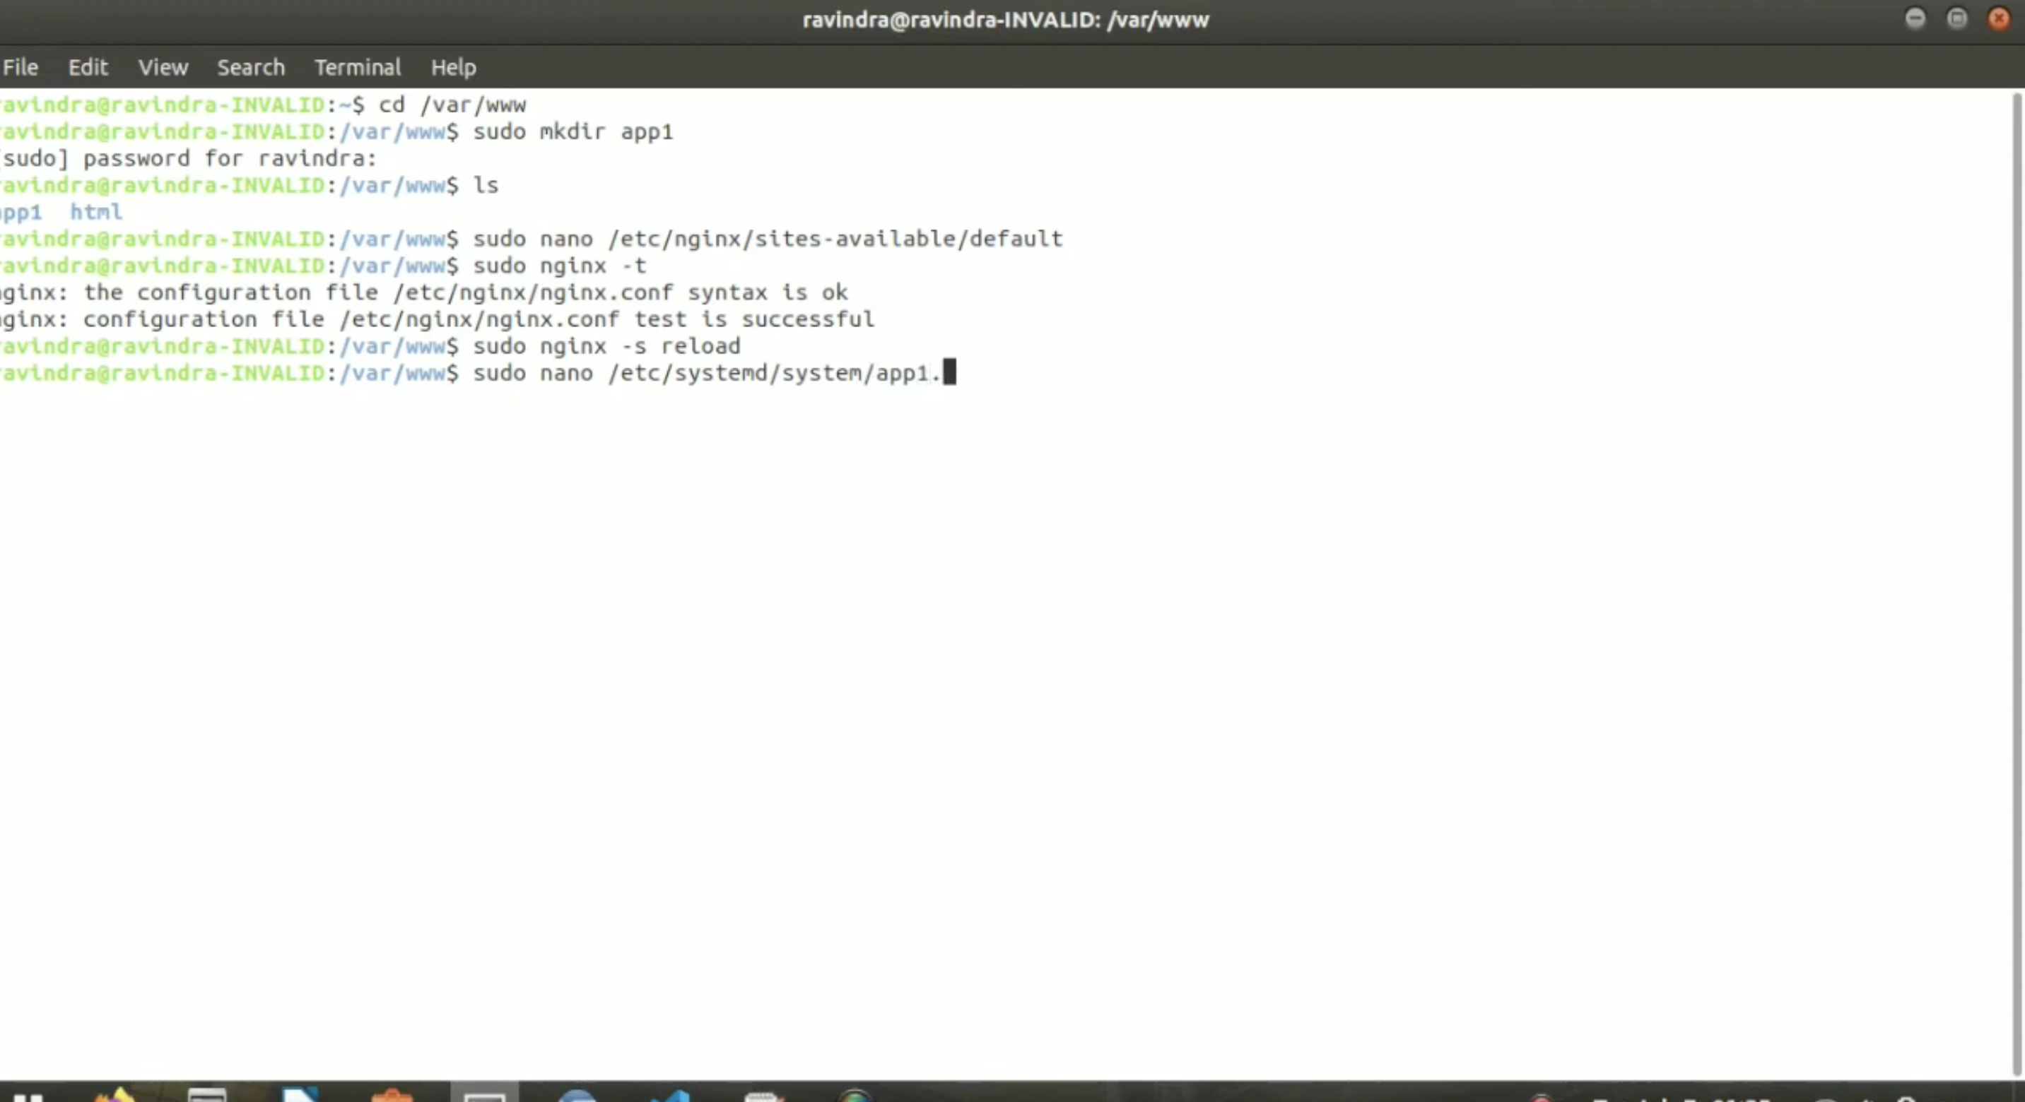
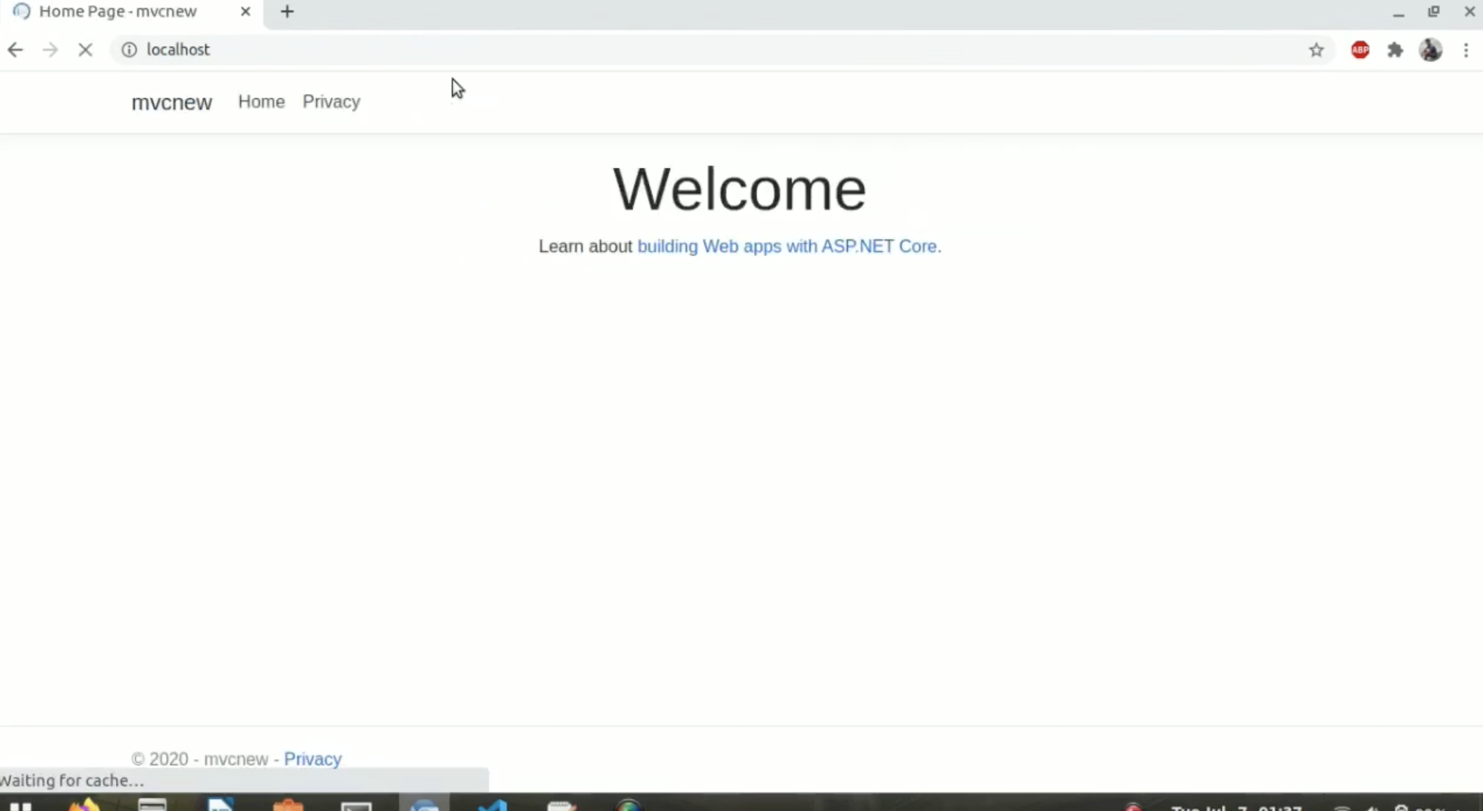

Most Linux distributions and BSD variants make NGINX Open Source available in their standard package repositories, but it’s usually not the latest version. We recommend downloading NGINX Open Source directly from nginx.org. There are just a few extra steps for adding the NGINX repository to the Ubuntu package manager (apt).
To install NGINX Open Source, follow these steps:
- Access your terminal.
- Download the NGINX signing key:
$ sudo wget http://nginx.org/keys/nginx_signing.key
- Add the key:
$ sudo apt-key add nginx_signing.key
- Change directory to /etc/apt.
$ cd /etc/apt
- Edit the sources.list file, appending this text at the end:
deb http://nginx.org/packages/ubuntu focal nginx
- deb-src http://nginx.org/packages/ubuntu focal nginx
Note: The focal keyword in each of these lines corresponds to Ubuntu 20.04. If you are using a different version of Ubuntu, substitute the first word of its release code name (for example, bionic for Ubuntu 18.04).
- Update the NGINX software:
$ sudo apt-get update
- Install NGINX:
$ sudo apt-get install nginx
- Type Y when prompted.
- Start NGINX:
$ sudo systemctl start nginx.service
- Check its status:
$ sudo systemctl status nginx.service
- Continue to Opening Your Web Page.

